Project Design Phase-II
Data Flow Diagram & User Stories

Date | 31 January 2025
Project Name | Employee raise issue
Maximum Marks | 4 Marks

Data Flow Diagrams:
The Employee Raise Issue application is designed to help employees report workplace concerns, IT issues, and service requests through a simple and structured process. The goal is to provide a centralized platform where requests can be submitted, tracked, and resolved efficiently, improving communication between employees and the support team.
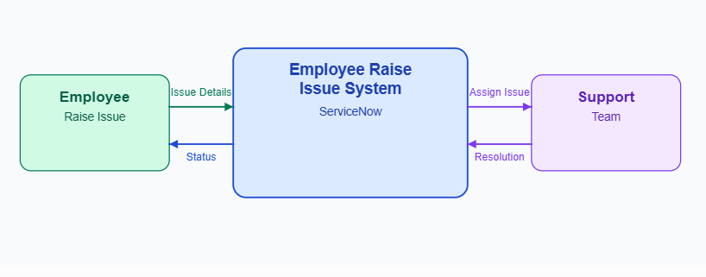
Example: Level 0 DFD (Context Diagram)

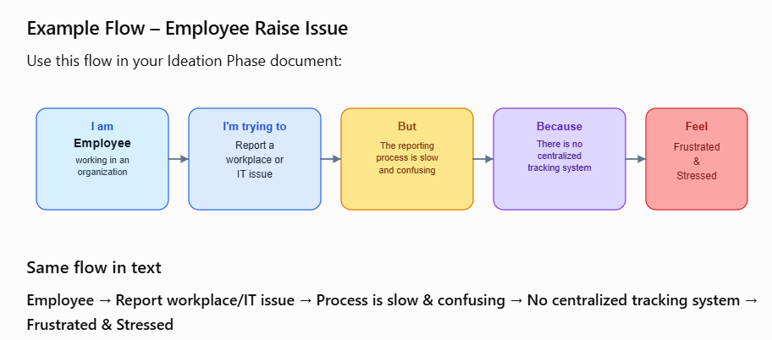

User Stories
Use the below template to list all the user stories for the product.
User Type | Functional Requirement (Epic) | User Story Number | User Story / Task | Acceptance criteria | Priority | Release
Employee | Raise Issue | USN-2 | As an employee, I can upload attachments with my issue. | Files are attached successfully. | Medium | Sprint-1
Employee | Track Issue | USN-3 | As an employee, I can view the status of my request. | I can receive confirmation email & click confirm | High | Sprint-1
Support Staff | Issue Management | USN-4 | As a support staff, I can update the issue status. | Employee receives the updated status. | High | Sprint-1
Administrator | Reports | USN-5 | As an administrator, I can view all employee issues | Admin can access and manage all records. | Medium | Sprint-2

